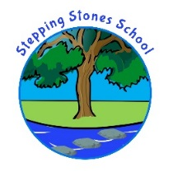
A daily checklist for your child’s return to school in September.
(check this every morning before you leave)

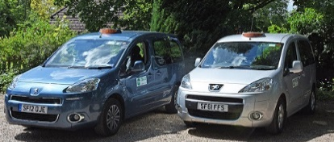
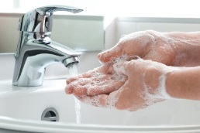
Regular handwashing before and after entering and exiting the taxi
and school site.

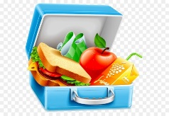
To bring to school a healthy packed lunch (where applicable) in a plastic lunchbox and your own water
bottle please - NO CLOTH lunch bags.

A healthy packed lunch (to mirror the school packed lunches) is:
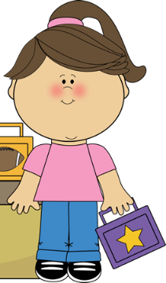
An sandwich or wrap A piece of A wafer or
with a healthy filling/ fruit piece of cake
or pasta salad
A packet of crisps A fruit yogurt
Or cheese crackers or fruit jelly
Or bread sticks

Bring sun cream to be self-applied; and a sun hat/cap for hot days.

------------------------------------------------------------------------------
Your child will be taking part in lots of outdoor learning experiences; please sign below if you give your permission for local trips, within a mile radius; and return this slip to school on your child’s first day back in September with the signed home school agreements.
I do give permission for _________________ to take part in local, outdoor
trips and experiences within a 1 mile radius. (September 2020 onwards)
Signed: _____________________________ Date: __________________

