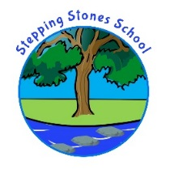
Return to School

September 2020

This document lays out the changes to rules and routines for this time to our School’s Positive Behaviour Policy (updated July 2020)

September 2020

The following changes will be circulated to all staff, pupils, parents/carers prior to the full re-opening of school. It clearly states key changes required during this time, relating to daily routines, rewards and sanctions, timetabling and use of PPE etc.

The circulation of the revisions will take the form of Newsletters; staff meetings; video-messaging; and face to face with parents where relevant.

Once on site, the new rules and routines will be regularly and rigorously reinforced throughout each school day with the pupils and staff; with daily training/time to absorb and discuss these changes with the whole staff.

Our normal approaches surrounding the need for high structure and fair and consistent approach remains the same.

For all children returning to Stepping Stones in September, there is a Home School Parental Agreement for both pupil and parents/carers to read and sign. This clearly states key changes, not solely practical changes to the classrooms and staffing, but rules surrounding strict hygiene practice and expectations for handwashing throughout our school day, with expectations for high standard of safety and respect for one another.

Our Three school rules remain the same:

- Be safe at all times
- Be respectful to everyone and the school at all times
- Complete learning tasks and activities to a high standard at all times

Key changes and rules are listed below:

- Times for arrival and departure will be staggered. Currently parents bringing and picking up their child are asked to wait at the school fence while their child hand washes before entering the building, to ensure the child is agreeing to this stringent need for good hygiene practice on site; and the parents are then asked to leave promptly. This will remain the same. Arrival and departure of taxis will be staggered, in the mornings between 9:00 and 9:15am; in the afternoons, between 2:40 and 2:45 pm; except for Fridays, when school will close at 1:30.
- New entry and exit procedures – each Bubble/Pod will have their own entrance/exit to minimise contact between bigger groups of people in school.
- The children will be taught in Bubbles (a class base) and will not socialise with other Bubbles in school. They will be expected to remain in their Bubble with their teacher and class teaching assistant for the day. 2 Bubbles will form a Pod.
- Expectations for staying within boundaries children will have their own furniture and will be expected to abide by the new boundary rules. Use of tape will clarify bubble boundaries where needed to support individuals. This has not been required during the Summer term provision, but may help when all children are back in school.

- Playtimes and lunchtimes will also be separate and staggered through the day to ensure no mixing between the Pods. Hygiene routines will be in place for the end of playtimes/ social times together.
- The rules and expectations about sneezing, coughing, tissues and disposal (‘catch it, bin it, kill it’) and avoiding touching your mouth, nose and eyes with hands remain the same and continues to be a high priority within Government guidance to reduce the spread of the virus.
- Coronovirus symptoms – this is clearly explained in the home school agreement also. If a child presents with any of the symptoms prior to school the expectation is they will not be in school and will be asked to get a test as per NHS guidelines. (see Appendix A). If a child presents with symptoms at school, the parents will be rung immediately for pick-up. A member of staff will remain with the child following Government guidelines re: wearing PPE (see below for further information on the use of PPE). There are clear guidelines for schools when/if this happens and we will of course be following them. Links for all further information, including testing are included at the end of this Policy.
- Children will not be allowed to bring any equipment in from home – unless there is a pre-arrangement with SLT. Children will have a personal stationary set of equipment provided for them at school. Anything brought in from home will be removed and returned at the end of the day, as per current school rules. If there is a persistent arrival of equipment from home, the equipment will remain at school and need to be collected by home.
- Learning Equipment all non- washable/sprayable toys and equipment will not be used within school.
- Each Pod will have access to their own set of toilets – again, to minimise contact between bigger groups of staff and pupils around school. Children will not be allowed to move to any other part of the school building other than their designated Bubble/Pod area.
- Coughing and spitting, or just threatening to cough and spit at or towards another person, be that a pupil or staff member, will be a clear indication that the pupil is not ready to access school provision. Further, rigorous risk assessments will take place and if appropriate further steps will be put in place to support the pupil and family in order for provision to be re-accessed.
- We are fully aware that our returning children will arrive with a range of needs regarding their thoughts, worries and concerns surrounding the pandemic. We will strive at all times to support your child, as we help them transition back into school rules, routines and learning. We ask for your full co-operation in supporting us with this and informing school of any worry or fear you know your child has; as well as informing us of any family crisis or loss there has been at this time. The more we know and can try to understand about a pupil’s current needs, the more we can support and help with any new difficulties and behaviours.
- Pupil Rewards (Appendix B): just as we would in normal times, we support the view that hard work and effort is to be rewarded. During this initial return to school, the children will be able to earn daily tokens. These tokens can be spent at the end of each day for showing respect, safety and a positive attitude towards their learning tasks and activities. The rewards will be from the “40 Bonus Box” selection” but with the opportunity to earn 1,2 or 3 items per day. A return to our original reward system will be looked at again in the future following our initial full return to school.
- Children on remote learning (in cases of local Lockdown/ school closure; or individual risk assessments), will also have the opportunity to earn rewards for showing respect, safety and a positive attitude towards their learning tasks and activities.
- At all costs we wish to avoid the need to use PPE – Personal Protective Equipment (Appendix C)– similar to that which you will have seen the NHS wearing during this crisis. However, both child and parent/carers need to understand that we will put this to use if a child is unable to manage our school rules and current changes and this results in challenging behaviours such as spitting, hurting and damage. We will have shared what this looks like – either face to face or through images in a Newsletter or video-messaging, as appropriate. It would in all cases cause extreme anxiety, but we wish to make clear that in order to keep all staff, pupils and their families safe, that the wearing of PPE in such a circumstance would be absolutely necessary. It is for this reason, that we cannot stress highly enough, the importance of your child being able to follow the school rules safely and with respect. If this is not the case, then the school provision will not be offered until there further risk assessments have taken place. Depending on the outcome, attendance on school site may or may not be offered at this time.
- For those pupils who refuse to follow all of the above rules and routines, put in place to secure the safety of all of our pupils, staff and families, further discussions with school and their parents/carers re: the appropriateness of their attendance at school at this time will take place.

Alongside the changes in rules, routines and expectations for our pupils and their families, below are listed the principles, as laid out in the Government Guidance, for all staff returning to work at this time:

Principles for Staff:

- Do not come to work if you have coronavirus symptoms, or go home as soon as these develop (informing your manager), and access a test as soon as possible.
- Clean your hands more often than usual - with running water and soap and dry them thoroughly or use alcohol hand rub or sanitiser ensuring that all parts of the hands are covered.
- Use the ‘catch it, bin it, kill it’ approach.
- Avoid touching your mouth, nose and eyes.
- Clean frequently touched surfaces often using standard products, such as detergents and bleach.
- Think about ways to modify your teaching approach to keep a distance from children in your class as much as possible, particularly close face to face support (noting that it’s understood that this is not possible at all times, which is why hygiene and hand cleaning is so important).
- Consider avoiding calling pupils to the front of the class or going to their desk to check on their work if not necessary.
- Help your class to follow the rules on hand cleaning, not touching their faces, ‘catch it, bin it, kill it’ etc. including by updating your classrooms displays with posters. (Appendix D )
- Prevent your class from sharing equipment and resources (like stationery).
- Keep your classroom door and windows open if possible for air flow.
- Limit the number of children from your class using the toilet at any one time.
- Limit your contact with other staff members, and don’t congregate in shared spaces, especially if they are small rooms.
- Make sure you’ve read the school’s updated behaviour policy and know what role in it you’re being asked to take.

Staff will need to explicitly teach and supervise health and hygiene arrangements such as handwashing, tissue disposal and toilet flushing.

Appendices

A Coronovirus Symptoms and Testing - see web address below

NHS test and trace: how it works

An overview of the NHS test and trace service, including hwat happens if you

test positive for coronavirus (COVID-19) or have had close contact with someone

who has tested positive.

https://www.gov.uk/guidance/nhs-test-and-trace-how-it-works

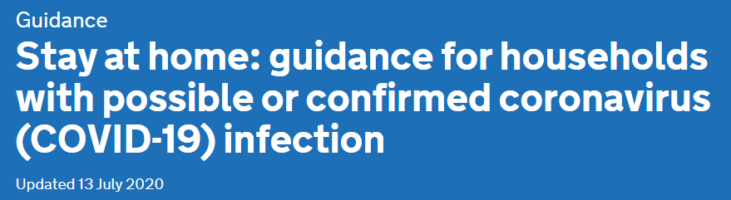

https://www.gov.uk/government/publications/covid-19-stay-at-home-guidance/stay-at-home-guidance-for-households-with-possible-coronavirus-covid-19-infection

- B Pupil Rewards

- C Crisis Procedure

- D Handwashing Advice and Classroom Resources

- E Government Guidance for parents with children returning to

School – see web address below

https://www.gov.uk/government/publications/what-parents-and-carers-need-to-know-about-early-years-providers-schools-and-colleges-during-the-coronavirus-covid-19-outbreak

Appendices

B Pupil Rewards

As explained above, just as we would in normal times, we support the view that hard work and effort is to be rewarded.
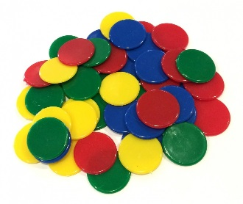
- During this initial return to school, the children will be able to earn daily tokens.

- These tokens can be spent at the end of each day for showing:
- Respect
- Safety
- A Positive attitude towards their learning tasks and activities
- For following their Behaviour Target

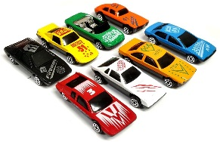
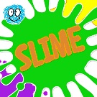
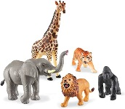
- The rewards will be from the “40 Bonus Box” selection”

- and with the opportunity to earn 1,2 or 3 items per day.

If you earn 20 - 25 tokens day – a ‘good’ day; following all SS school rules. | 1 item from the reward box
26 – 40 tokens a day – above and beyond throughout the day | 2 items from the reward box
40+ tokens a day – safe, good choices e.g. when it would have been crucial to follow adult instructions | 3 items from the reward box

Certificates of celebration will continue to be used to celebrate daily and weekly achievements.

A return to our original reward system will be looked at again in the future following a full return to school.

Appendices

C Crisis Procedure

- In the event of a child refusing to comply with the school behaviour policy in terms of safety i.e. spitting, hurting, damage/ threatening to spit, hurt and damage – at or towards another – the use of PPE will be used.

- Each Bubble base will have 2 sets of PPE – visor, face mask, apron, gloves.

- In the first instance where a child has not responded to the school’s usual procedures of support – de-escalation, verbal support and options given e.g. removing themselves to a safe place, asking for help etc, the staff in the Bubble base will call for assistance using the walkie-talkie.

- The staff will then put on the PPE and await assistance from the Senior Leadership Team (SLT), who will also be wearing PPE.

- Physical restraint will be used if required, due to the child not responding to the usual support and is continuing to put themselves or others at risk.

- The child, if still unable to respond to verbal support and instructions re: keeping safe, will leave the class with the SLT.

- Parents/Carers will be called to collect the child immediately.

- Further risk assessments will then take place with SLT, Parents/Carers/the child/ and any other agency as appropriate. Depending on the outcome, attendance on school site may or may not be offered at this time.

Appendices

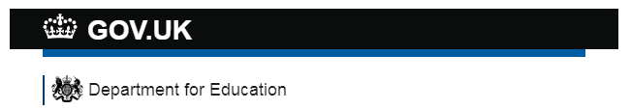

D Handwashing Advice

It is essential that everyone washes their hands more often, using soap and water for at least 20 seconds. Hand washing with soap employs mechanical action that loosens bacteria and viruses from the skin, rinsing them into the drain. Drying hands afterwards makes the skin less hospitable to the virus. Hand sanitiser can be effective if soap is not available or the situation makes using soap less feasible (i.e. when outside) but using hand sanitiser provides none of the virus-destroying friction that rubbing your hands together and rinsing with water provides.
The latest guidance and video on hand washing can be found at:
• https://www.gov.uk/guidance/coronavirus-covid-19-information-for-the-public
The e-Bug project is led by Public Health England and has a dedicated webpage for learning resources on hand washing and respiratory hygiene.
Resources are currently available for KS1, KS2 and KS3 and can be used in various settings including schools and at home:
• https://e-bug.eu/

