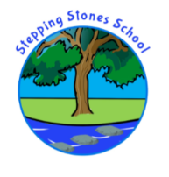

stepping stones HOmE SCHOOL AGREEMENT - sEPTEMBER 2020

The Government published further guidance at the beginning of July for the full re-opening of schools. Although, there could be changes during the summer holidays we will be working hard to ensure we have more children back in school from September. This Home School Agreement outlines the provision at Stepping Stones and the guidelines and procedures in place for a COVID-19 safe environment and how the possible risk to security and safety are being managed for both pupils, parents and staff and their families.

Stepping Stones has remained open for vulnerable children and children of key workers during the COVID-19 outbreak. The Government have stated that schools should be making plans for all children to return in September.
As an Alternative Provision Provider the risk of pupil behavioural issues is high risk, therefore we have made significant changes to the school day. We have to lower the risk and we have done this through changes to the curriculum, both to ensure realistic expectations as well as ensure an appropriate catch-up programme; and ensured all systems and procedures in place protect staff due to the high risk of unsafe behaviours.
During the past 6 weeks (Summer Term) we have not been following the full National Curriculum. As you know, it has continued to follow the format of the home learning packs,(children on roll 2019-2020) with some additional outdoor learning on school site.
This provision has been successful in easing transition back into school life, whilst also ensuring safety and social distancing measures are adhered to. It has to be safe for staff, your child and everyone’s families. From September, there will continue to be a high focus on outdoor learning, as well as changes to the day’s timetable in order to ensure we remain COVID-19 secure and lower the risk to staff from unsafe behaviours; as well as to continue to ease the transition into school for both out present and new pupils.

For some pupils, they have been out of school for 5 months by this time. Therefore school provision will be dependent following risk assessment and discussion with parent, pupil and any other agencies where applicable. Mainstream schools will complete a behavior risk assessment for their pupils attending Stepping Stones on a referral placement.
School provision for some will therefore form a gradual introduction back to school learning and safety expectations.

For our current children, they may not be with their previous class teacher/peer group or classroom, as is the norm in many schools for the Autumn Term. In their class group, which will be known as a Bubble, they will spend the whole day together and will not mix with the other Bubble(s) around the school.
Two Bubbles are able to form a Pod and will share social times, wash facilities and staffing.

A Bubble – will consist of 2 staff and a maximum of 8 (5-6 in September) children based in one classroom; playtime and lunch time will be staggered with the other Bubble(s) and Pod. Each pair of Bubbles will have its own entry point and exit point, sanitization stations and wash facilities separate to the other Pod.
We envisage that school will start from 9am – 9:30 (Staggered arrival times)
School will finish from 2:40 – 2:45 (Staggered departure times)
Every Friday school will close at 1:30pm for deep cleaning and to ensure teachers get their allocated time.
We are minimising the amount of contact between every Bubble, therefore we are not wanting to send additional staff into each bubble or cross contaminate each bubble.
As in usual term time, the teachers will now not only be providing a structured routine and learning activities throughout the day, but will be teaching all subjects across the National Curriculum.
The behaviour policy and practice will be very different.
As mentioned above, where possible we will be aiming to complete a lot of tasks outside (weather dependent).

School Staff will continue to:
- Expect the rules of safety, respect and doing the tasks, to be completed without oppositional / refusal behaviours. (See Addendum to Behaviour Policy)
- Be symptom free (as best to our knowledge)
- Be following the Department for Education guidance on socially distancing in and out of school.
- Be re-organising the classroom environment, routines and structures to adhere to the socially distancing rules and increased hygiene procedures.
- Be minimising the amount of furniture around the rooms.
- Allocate each child a chair and work area.
- Be actively following Government Guidance for keeping safe. (dependent on what is current at the time)
- Open from above times.
- Provide a safe environment for your child - which will include regular hand washing, staff regularly cleaning and enforcing high expectations for hygiene, germ prevention.
- Phone any parent if their child is displaying symptoms of COVID-19 or displaying high risk behaviours which will include refusal to engage in regular hand washing and have the expectation for them to collect their child. There will be individual risk assessments in place for each child and appropriate strategies according to each pupil’s risk.

Parents / Carers are requested to do the following:
- Be symptom free within their household and ensure that their child is symptom free prior to accessing the school provision.
- The family should be following the government guidance, current at the time. There will of course be updates by September.
- Follow the most up-to-date Government guidance in terms of social distancing and test and trace procedures if and when required.
- Have their phones to hand at all times and answer all calls from school. You may be expected to collect your child if they are refusing to complete the agreed tasks or displaying high risk behaviours or have started to display Covid-19 symptoms.
- To teach your child about hygiene, sneezing into a tissue, coughing into their elbow, hand washing and practice social distancing at home prior to bringing them to school. There are lots of resources to explore on https://e-bug.eu/junior_pack.aspx?cc=eng&ss=2&t=Hand%20Hygiene
- Talk to your child about social distancing and how teachers will be available for them but at the 2m distance. Current Guidance states that there is no social distancing for pupils, however, it is advised that the 2m rule is kept between staff and staff and pupils. We recognize that this is very difficult especially with our younger pupils, however, we will continue to support their understanding and remain risk sensible at all times. With home and school working together, we will reduce any anxiety your child may have.
- Prepare your child for the changes in school – talk to them about how things are different at the moment. Explain the school day will be different, they will be in a different room and have different routines – where this applies. (We have provided a Summer Holiday Pack, attached, where information such as visual stories are included to support you doing this.)
- Have completed the Back to School preparation pack e.g. engaged your child in some learning throughout the holiday to support the transition back to school and expectations around learning; have ensured routines are in place for mornings and bedtimes; uniform is in place; have shared key information with school surrounding your child’s Lockdown Experience, where relevant. For example if there has been a bereavement; high anxiety around particular aspects; high anxiety surrounding a return to school etc.
- Please provide your child with a healthy packed lunch and a water bottle. (Please see what we allow and do not allow)
- Or, as explained in the school newsletter, LCC Catering team is providing a new packed lunch menu which will vary daily and have a wide range of choices available including hot pastries, pasta dishes and sandwiches, which will be delivered to school.
- Follow the pre-school routines and after school routines outlined below.
- Provide your child with a P.E. kit which must consist of: a plain T-shirt and shorts; plain sweatshirt and tracksuit bottoms and trainers. We are unable to provide any P.E. kit in school.
- On P.E. days in the autumn term, we are asking the children to arrive at school in their PE kit. We will let you know on which day this will be at the start of the autumn term.

ALL CHILDREN ACCESSING THE PROVISION ARE EXPECTED TO
- Be safe, be respectful and do what is asked at all times.
- Following handwashing guidance regularly through the day.
- Where possible follow the social distancing rules.
THERE IS NO ACCESS TO SCHOOL THROUGH THE MAIN ENTRANCE – PARENTS / CARERS SHOULD NOT COME ONTO THE SITE UNLESS REQUESTED TO. PARENTS/ CARERS SHOULD NOT COME INTO THE SCHOOL BUILDING UNLESS REQUESTED TO. If you require to speak with someone – indicate this to the adult on arrival / departure procedures for this to be arranged.
Pre School
- Prior to leaving the house the child and family members should wash their hands for 20 seconds.
- Children may get into a taxi with a Passenger Assistant and Driver who will have PPE on e.g. face masks. Your child’s behaviour must be safe and predictable or transport will be refused.
- On arrival to school, the school gate will be open. Staff will direct your child to their base.
- Passenger assistants should stand at the fence and wait until a staff member says they can leave.
- The child will walk to their sanitization station where they will be greeted by an adult and asked to clean their hands prior to entering the building. If the child refuses then we will make attempts to engage the child. If they do not engage parents will be called.
- The child will enter via their allocated entry point.
BEHAVIOURAL INCIDENTS
Stepping Stones is an alternative provision provider with lots of experience of working with children with complex social, emotional and behavioural difficulties. However, given the current guidance and pandemic we are not able to provide our normal school provision. We are not going to put staff or children at risk by physically intervening. We are not able to provide the same level of nurture, emotional support in the form of touch, hugs and cuddles. If a child does display complex and challenging behaviour then all staff will carry out a dynamic on the spot risk assessment and call for the SLT member to make an informed judgement on next steps.
If the children are presenting a risk to themselves, making threats to hurt, spit, lash out, damage, or actually carrying out these activities parents will be called immediately to collect. (Again, as mentioned above, this will be dependent on individual pupil risk assessments)
Staff have been equipped with PPE (Personal Protection Equipment) If required, staff will be kitted out in PPE and move the child away from their group until a parent collects. The provision will then be reviewed and Local Authority advice would be sought immediately.

The risk assessment will be reviewed, a discussion will take place with the local authority, in terms of future provision to be offered. The staff may make the decision to remove the other children from the room to a backup space, whilst staff in PPE enter the room and make the situation safe.
Restraint to prevent a child causing significant damage, hurting others and hurting staff will only be in extreme circumstances and be risk assessed by the Senior Leader in charge. Children that require this level of support will be deemed high risk and therefore provision will have to be reviewed with a Local Authority officer in line with their risk assessment. Parents would be called immediately to collect their child as they would be putting others at significant risk of harm. (limited staffing structure, risk of infection despite not having symptoms etc.)
We are of course following Government guidance and advice to support all of our vulnerable pupils. It is important we consider all aspects surrounding a child’s needs when conducting a risk assessment as explained below.
Now the Government’s five key tests have been met, it is appropriate for educational settings and local authorities, working with families, to bring back all children and young people who have not been attending their educational setting. This will be based on individual risk assessments and within the limits of what the educational setting is capable of accommodating, given any staff absences, local lockdowns, staff isolating due to test and trace and naturally to remain in line with the need for the protective measures.
Essential measures for full re-opening in September include:
- a requirement that people who are ill stay at home
- robust hand and respiratory hygiene
- enhanced cleaning arrangements
- active engagement with NHS Test and Trace
- formal consideration of how to reduce contacts and maximise distancing between those in school wherever possible and minimise potential for contamination so far as is reasonably practicable.
How contacts are reduced will depend on the school’s circumstances and will (as much as possible) include:
- grouping children together
- avoiding contact between groups
- arranging classrooms with forward facing desks
- staff maintaining distance from pupils and other staff as much as possible.

In any risk assessment, employers must protect people from harm. This includes taking reasonable steps to protect staff, pupils and others from coronavirus (COVID-19) within the education setting.
As you have read, we are taking all reasonable steps to protect our school community and its families in order to meet the Government guidelines and advice re: remaining COVID-19 secure.

We trust you are understanding of the measures and procedures we have now put in place in order to facilitate a safe return to school for all pupils and staff; and understand the measures we will need to enforce if there are serious incidents concerning high risk behaviours from your child.
Once reading all of the above, please complete the agreement form on Parent App.
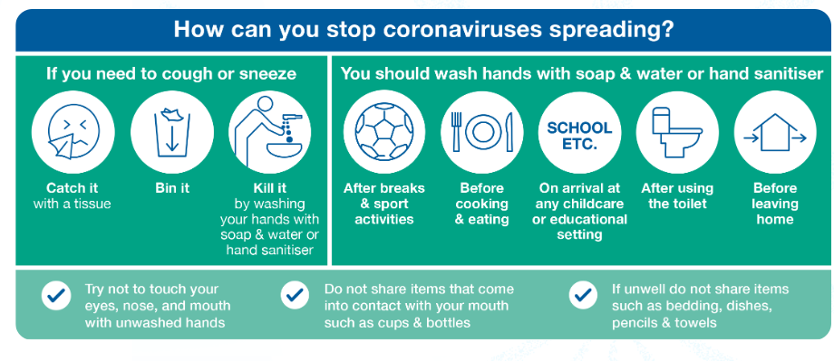
Or alternatively the attached sheet and bring to school on your return in September.

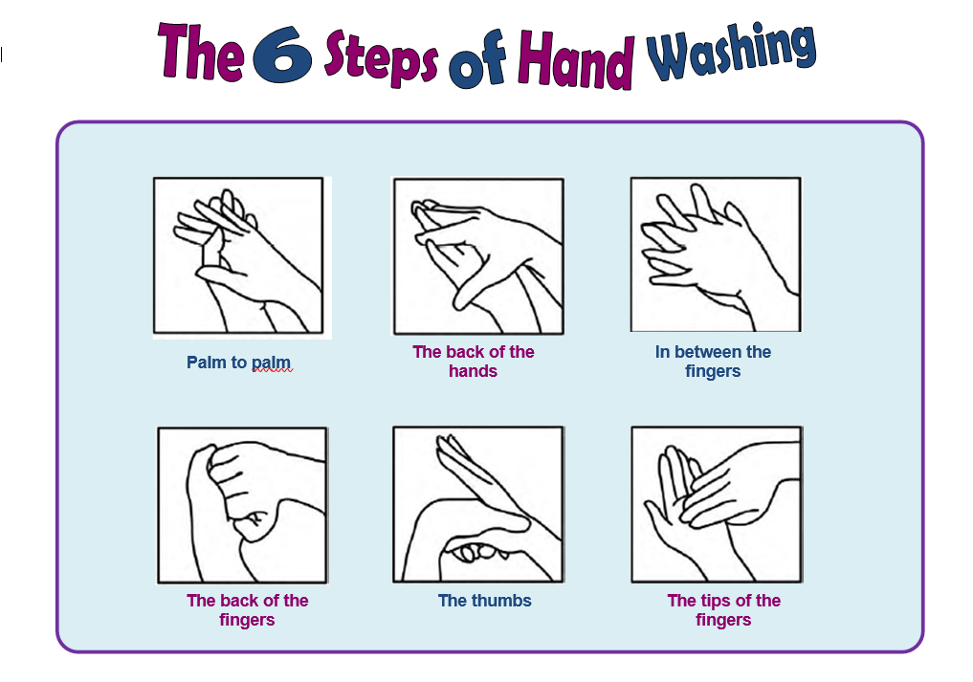

stepping stones HOmE SCHOOL AGREEMENT - sEPTEMBER 2020

I/ We _______________________________________ have read all of the information regarding Stepping
Stones return to/ starting at Stepping Stones school provision, Autumn Term 2020, (there may be further changes during the Autumn term 2020).
I/ We understand our responsibilities to ensure our child understands the measures in place in school.
I/ We have discussed all of the above and talked to our child about the expectations and provision for a return to school.
I/ We will have a healthy packed lunch (where applicable), and water bottle for our child each day they attend.
My child has agreed to take their medication which will be given to them in a medical cup from a safe distance.
I/ We will have our phone on and answer calls immediately.
I/ We fully support the school and will collect our child if there has been a behavioural incident; if they display signs and symptoms of illness; or struggle to adhere to the social distancing and hand washing / hygiene regimes.

Signed __________________________________________ DATE __________________________
Print name: ______________________________________
Signed __________________________________________ DATE __________________________
Print name: ______________________________________

Child Agreement
I will do my best to keep everyone safe.
I will do what adults ask.
I will follow social distancing rules.
I will wash my hands for 20 seconds regularly through the day.
I will take my medication as expected.

SIGNED CHILD _____________________________________ DATE ______________________

