Stepping Stones School Behaviour Blue Print
2022-2023

Our School Values are:
Respect
Kindness
Tolerance
Trust

Our 3 School Rules are:
- Be Safe
- Be Respectful
- Complete Learning to a high standard

T
Our Restorative Questions – Restore and Repair
- What’s happened? | 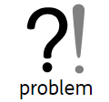
- What were you thinking at the time? | 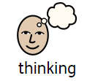
- How did this make you / others feel? | 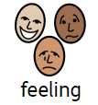
- How can we make things better because I care about your actions? | 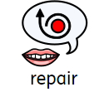
- What have we learned? How would we handle this if it happened again? | 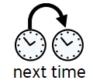

Emotion Coaching Script
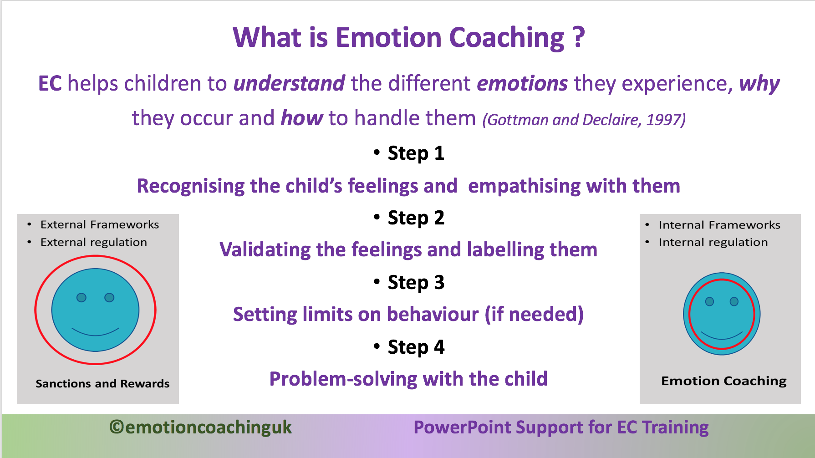

SLT will be involved in serious incidents and be part of the restorative decisions. Parents / Carers are expected to support the school in ensuring their child is safe and is not putting staff, other pupils and the environment at risk. This will be part of risk reduction meetings.
Pupil’s will have a risk assessment and positive handling plans in place.

30 Second Scripts
- We care about you and expect you to….
- I can see that something has triggered you…. Can I help.
- You are breaking the rule of XXX I expect to see…. Thank you.
Our Behaviour Strategy
First attention for positive behaviour | - Acknowledge good behaviour choices 2:1  - Use positive praise  - Use positive reinforcement to re-engage  - Allow take up time  - Use non-verbal reminders  - Listen to the pupil
DEESCULATION & IGNORE WHAT CAN BE IGNORED FOCUSSING ON THE CHILDREN MAKING POSITIVE CHOICES
Reminder  Keep Language MINIMAL | - Clear, scripted, say it in 30sec & allow time.  - TA / Teacher to move towards the child and quietly remind them of expectations. This may mean an adult sits with the child.  - Remind the child of the rules. E.g. At Stepping Stones we put our hand up. I expect you to…. Please follow the rule of XX by….  - Non-confrontational / no arguments. The class expectation is…. I can see you are finding something hard, let me help by….
Offer of time in class – SAFETY! | - Give the child time to rectify and make positive choices.  - Make them aware of the behaviour. “You are talking when I am teaching, please listen.”  - I can see that you are XXX... Use your toolkit, take a minute at your table / area.  - I want to see you XXXX. Remind child that they may have to give time back.
Time out – impact on others | - Name, I am asking you to take a few minutes with TA . This Is to support you.  - Name, your behaviour is disrupting the other children. Please take time in the XX. Praise the child when they take themselves. I expect you to go safely.
Child is displaying dangerous behaviour / refusing to take time out which is significantly impacting on others | - NAME, You need to take yourself to XX. I can see you are feeling upset…. Take yourself safely. (UNLESS THE CHILD IS DISPLAYING UNSAFE BEHAVIOUR THEN 3 ATTEMPTS SHOULD BE MADE TO GET THEM TO TAKE THEMSELVES.)  - Remind them of need to pay time back if appropriate.  - Staff should only intervene if a child is presenting high risk behaviour.
REPAIR, RESTORE | - ALWAYS HAVE A RESTORATIVE CONVERSATION. Child will have to give time.

All adults at Stepping Stones School strive to be:
- Meeting and Greeting children daily – and check in through the day.
- Calm, consistent, attuned approaches.
- Relentlessly positive, and genuine that have high expectations for everyone. (Body language and face say genuine)
- Nurturing and build relationships with unconditional positive regard for all
- Committed to supporting regular opportunities to reflect, repair and restore all relationships.

