
“A Can Do School”
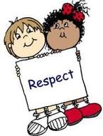
PUPIL agreement
IN SCHOOL
- I will BE SAFE with my words and actions.
- I will take myself to a place of safety when I am struggling.
- I will BE RESPECTFUL to everyone.
- I will COMPLETE MY LEARNING TO A HIGH STANDARD.

Before and After school I will…
- go to bed at a sensible time.
- wear school uniform EVERY day.
- not bring items to school inc. electronic devises, phones.
- stay safe in the taxi.
- read to my parents/carers at home, share learning and
times tables.

Signed………………………………………………

Date: ……………………………………………….

