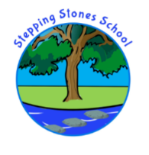
“A Can Do School”

OUR SCHOOL EXPECTATIONS

2023-2024

At Stepping Stones School we are committed to EVERY child receiving a high quality education. We promote the core values of:

Respect
Kindness
Tolerance
Trust

We also have three key rules

Be Respectful—with words and actions
Be Safe— hurting and damage is never ok
Complete your learning to a high standard– always try your best

We expect that every child, staff member and parents work together positively, consistently and supportively to achieve the best outcomes.

