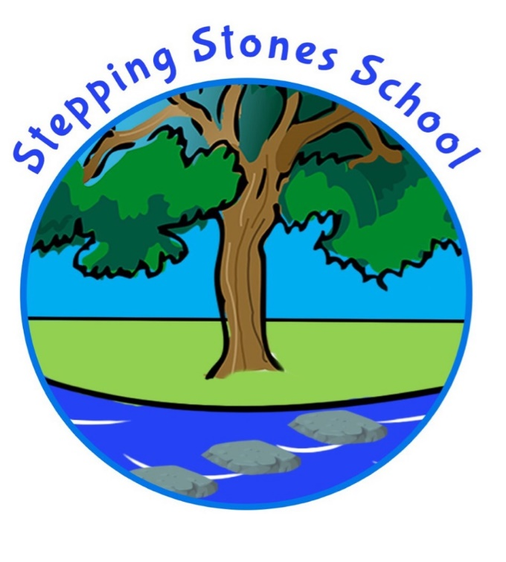

Privacy Notice (How we use pupil data)

Shared with Staff : September 2023

This notice is to help you understand how and why we collect pupil personal information and what we do with that information. It also explains the decisions that you can make about this information.

Stepping Stones School is the data controller of the pupil personal information you provide to us. This means that the school determines the purposes for which, and the manner in which, any personal data relating to pupils and their families is to be processed.

The School Business Manager is the Data Protection Officer (DPO). The DPO role is to oversee and monitor the school’s data protection procedures, and to ensure they are compliant with the General Data Protection Regulations (GDPR). The DPO can be contacted on 01524 67164 or email bursar@steppingstones.lancs.sch.uk

Further information regarding the GDPR, and the commitment by Stepping Stones School to be data protection compliant, can be found in the school’s GDPR policy - a copy of this can be found on the school website - https://www.steppingstones.lancs.sch.uk

The categories of pupil information that we collect, hold and share include:

• Personal information (such as name, unique pupil number, contact details, views through pupil and parent questionnaires and safeguarding data)

• Characteristics (such as ethnicity, language, nationality, country of birth, free school meal eligibility and pupil premium eligibility)

• Safeguarding information – eg court orders and professional involvement

• Attendance information (such as sessions attended, number of absences and absence reasons)

• Assessment information and Attainment (such as results of statutory tests and on going teacher assessments)

• Medical information given to us by parents and other third parties such as NHS Trusts, GPs and allied medical professionals (eg physiotherapists, sight and hearing professionals)

• Special Educational Needs and Disability Information – owing to the specialism of Stepping Stones School we hold SEND data such as personal and social notes

• Behaviour and exclusions information – both internal and external

Why we collect and use this information

We use the pupil data:
• to support pupil learning
• to keep pupils safe
• to meet legal requirements and legitimate interests placed on us by the Government
• to monitor and report on pupil attainment and progress
• to provide appropriate pastoral care
• to assess the quality of our services
• for identification and safeguarding purposes
• to provide pupils with a voice
• to tailor individual needs of pupils such as medical, behaviour and care plans

The lawful basis on which we use this information

The conditions for processing data under the GDPR will be:

Article 6

1. Processing shall be lawful only if and to the extent that at least one of the following applies:
a) Data subject has given consent
b) Necessary for the performance of a contract such as Education Transport and IT access
c) Compliance with Stepping Stones Schools legal obligations such as School Census
d) To protect the vital interests of the data subject or of another person such as providing medical information to emergency services
e) For the performance of a task carried out in the public interest or in the exercise of official authority invested in Stepping Stones School
f) Necessary for the purposes of the legitimate

Article 9

1. Processing of personal data revealing racial or ethnic origin, political opinions, religious or philosophical beliefs, or trade union membership, and the processing of genetic data, biometric data for the purpose of uniquely identifying a natural person, data concerning health or data concerning a natural person’s sex life or sexual orientation shall be prohibited.
2. Paragraph 1 shall not apply if one of the following applies:

(j) Processing is necessary for archiving purposes in the public interest, scientific or historical research purposes or statistical purposes in accordance with Article 89(1) based on Union or Member State law which shall be proportionate to the aim pursued, respect the essence of the right to data protection and provide for suitable and specific measures to safeguard the fundamental rights and the interests of the data subject.

The Education (Information about Individual Pupils) (England) Regulations 2013 - Regulation 5 'Provision of information by non-maintained special schools and Academies to the Secretary of State' states 'Within fourteen days of receiving a request from the Secretary of State, the proprietor of a non-maintained special school or an Academy (shall provide to the Secretary of State such of the information referred to in Schedule 1 and (where the request stipulates) in respect of such categories of pupils, or former pupils, as is so requested.'

The Education Act 1996 - Section 537A – states that we provide individual pupil information as the relevant body such as the Department for Education.
Children's Act 1989 – Section 83 – places a duty on the Secretary of State or others to conduct research.

Collecting pupil information

Whilst the majority of pupil information you provide to us is mandatory, some of it is provided to us on a voluntary basis. We collect the majority of pupil personal data via the following methods:
• Registration and Admission Papers
• Common Transfer Files (CTF) from previous schools
• Child Protection Plans
• Pupil Paper Files from the previous school
• Via LCC School Portal
• Via Department of Education downloads

How long do we keep your data?

Data relating to pupils at Stepping Stones School and their families is stored in line with the school’s General Data Protection Policy. A copy of this can be found on the school website - https://www.steppingstones.lancs.sch.uk - or you may request a printed copy via the School Office.

In accordance with GDPR, the school does not store personal data indefinitely: data is only stored for as long as is necessary to complete the task for which it was originally collected. Our school’s retention schedule is detailed as an Appendix E in the GDPR policy.

Sharing Pupil Information

We routinely share pupil information with:
• schools that the pupil’s attend before us or after leaving us
• our local authority and local authorities as applicable
• School Nurse – Virgin Care Services Limited
• Approved contractors such as Education Transport Providers and ICT Support
• the Department for Education (DfE)
• Children’s Social Care
• Longlands Child Development Centre
• Children and Family Wellbeing Service
• Child Action North West
• Blackpool Fylde and Wyre NHS Trust
• Lancashire Child, Adolescent Mental Health Service (CAMHS)
• University Hospitals of Morecambe Bay NHS Foundation Trust
• Lancashire Care NHS Trust
• Communication Tools such as Classdojo
• Third Party Providers eg Morecambe Football Club, Extended Service Activity, Residential Settings (Winmarleigh)
• Charities for supporting families in need (only after informing individual families)

Why we share pupil information

We do not share information about our pupils with anyone without consent unless the law and our policies allow us to do so.

We share pupils’ data with the Department for Education (DfE) on a statutory basis. This data sharing underpins school funding and educational attainment policy and monitoring.

We are required to share information about our pupils with our local authority (LA) and the Department for Education (DfE) under section 3 of The Education (Information About Individual Pupils) (England) Regulations 2013.

Data collection requirements:

To find out more about the data collection requirements placed on us by the Department for Education (for example; via the school census) go to https://www.gov.uk/education/data-collection-and-censuses-for-schools.

Parent and Pupil Rights

Parents and pupils have the following rights in relation to the processing of their personal data:
• Be informed about how Stepping Stones School uses personal data.
• Request access to your child’s personal data that Stepping Stones School holds
• Request that your child’s personal data is rectified if it is inaccurate or incomplete.
• Request that your child’s personal data is erased where there is no compelling reason for its continued processing.
• Request that the processing of your child’s data is restricted.
• Object to direct marketing and processing for the purposes of scientific and/or historical research and statistics.

Where the processing of your child’s data is based on your consent, you have the right to withdraw this consent at any time.

If you have a concern about the way Stepping Stones School and/or the DfE is collecting or using your child’s personal data, you can raise a concern with the Information Commissioner’s Office (ICO). The ICO can be contacted on 0303 123 1113, Monday-Friday 9am-5pm

Access To Personal Data

Under data protection legislation, parents and pupils have the right to request access to information about them that we hold. To make a request for personal information, or be given access to your child’s educational record, contact our Data Protection Officer on 01524 67164.

You also have the right to:
• object to processing of personal data that is likely to cause, or is causing, damage or distress
• prevent processing for the purpose of direct marketing
• object to decisions being taken by automated means
• in certain circumstances, have inaccurate personal data rectified, blocked, erased or destroyed; and
• claim compensation for damages caused by a breach of the Data Protection regulations

If you have a concern about the way we are collecting or using personal data, we request that you raise your concern with us in the first instance. Alternatively, you can contact the Information Commissioner’s Office at https://ico.org.uk/concerns/

The National Pupil Database (NPD)

The NPD is owned and managed by the Department for Education and contains information about pupils in schools in England. It provides invaluable evidence on educational performance to inform independent research, as well as studies commissioned by the Department. It is held in electronic format for statistical purposes.

This information is securely collected from a range of sources including schools, local authorities and awarding bodies.

We are required by law, to provide information about our pupils to the DfE as part of statutory data collections such as the school census and early years’ census. Some of this information is then stored in the NPD. The law that allows this is the Education (Information About Individual Pupils) (England) Regulations 2013.

To find out more about the NPD, go to https://www.gov.uk/government/publications/national-pupil-database-user-guide-and-supporting-information.

The Department for Education is legally allowed to share pupils personal information with certain third parties including the following:
• Schools
• Researchers
• Organisations connected with promoting the education or wellbeing of children in England
• Other government departments and agencies
• Organisations fighting or identifying crime

The Department has robust processes in place to ensure the confidentiality of our data is maintained and there are stringent controls in place regarding access and use of the data. Decisions on whether DfE releases data to third parties are subject to a strict approval process and based on a detailed assessment of:
• who is requesting the data
• the purpose for which it is required
• the level and sensitivity of data requested: and
• the arrangements in place to store and handle the data

To be granted access to pupil information, organisations must comply with strict terms and conditions covering the confidentiality and handling of the data, security arrangements and retention and use of the data.

For more information about the department’s data sharing process, please visit: https://www.gov.uk/data-protection-how-we-collect-and-share-research-data

For information about which organisations the department has provided pupil information, (and for which project), please visit the following website: https://www.gov.uk/government/publications/national-pupil-database-requests-received

To contact DfE: https://www.gov.uk/contact-dfe

