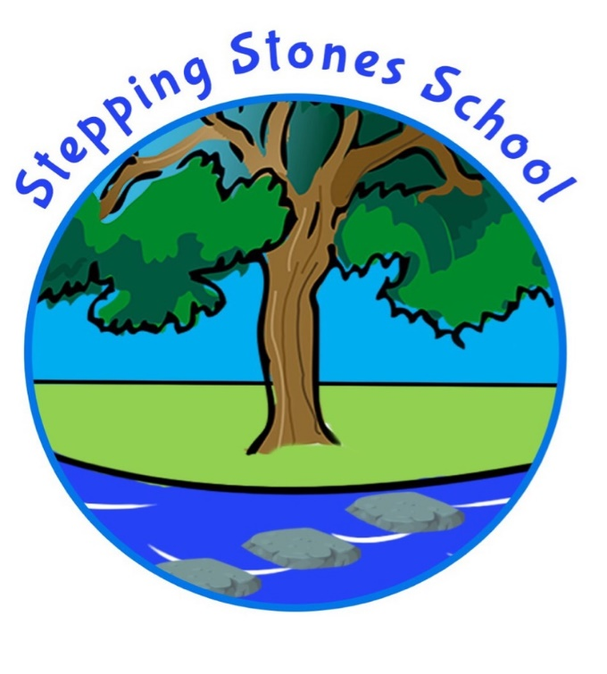

Privacy Notice (How we use school workforce information)

Shared with Staff : September 2023

GDPR applies to ‘controllers’ and ‘processors’. The controller says how and why personal data is processed and the processor processes data on behalf of the controller.

The school is the data controller. Anyone who processes data on behalf of our school is a data processor.

The school is the data controller of the personal information you provide to us. This means the school determines the purposes for which, and the manner in which, any personal data relating to staff is to be processed. We do not share information about workforce members with anyone without consent unless the law and our policies allow us to do so.

GDPR applies to personal data. That is, any data that can be used to identify a person.

For example, pupil records, governor records, contact lists, parents/carer records. The person who the data is about is called the data subject.

The School Business Manager is the Data Protection Officer. The role is to oversee and monitor the school’s data processing practices. This individual can be contacted on 01524 67164 or bursar@steppingstones.lancs.sch.uk

Where necessary, third parties may be responsible for processing staff members’ personal information. Where this is required, the school has in place checks regarding data protection requirements on third party processors. This ensures that your data is processed in line with staff members’ privacy rights.

The categories of school workforce information that we collect, process, hold and share include:

- personal information (such as name, employee or teacher number, national insurance number, payroll information, employment details)
- special categories of data including characteristics information (such as gender, age, ethnic group and medical information)
- contract information (such as start dates, hours worked, post, roles and salary information)
- work absence information (such as number of absences and reasons)
- qualifications (and, where relevant, subjects taught)

Why we collect and use this information

The collection of personal information will benefit the school, Department for Education and Local Authority by:
- Improving the management of workforce data across the sector.
- Enabling the development of a comprehensive picture of the workforce and how it is deployed.
- Contractual requirements including payroll
- Employment checks eg right to work in the UK
- Informing the development of recruitment and retention policies.
- Allowing better financial modelling and planning.
- Enabling ethnicity and disability monitoring.
- Supporting the work of the school teachers’ review body.
- Enable IT systems such as online payments, text messaging and staff on site management
The lawful basis on which we process this information

The conditions for processing data under the GDPR will be:

Article 6

1. Processing shall be lawful only if and to the extent that at least one of the following applies:
a) Data subject has given consent
b) Necessary for the performance of a contract such as Education Transport and IT access
c) Compliance with Morecambe Road Schools legal obligations such as School Census
d) To protect the vital interests of the data subject or of another person such as providing medical information to emergency services
e) For the performance of a task carried out in the public interest or in the exercise of official authority invested in Morecambe Road School
f) Necessary for the purposes of the legitimate

Article 9

1. Processing of personal data revealing racial or ethnic origin, political opinions, religious or philosophical beliefs, or trade union membership, and the processing of genetic data, biometric data for the purpose of uniquely identifying a natural person, data concerning health or data concerning a natural person’s sex life or sexual orientation shall be prohibited.

2. Paragraph 1 shall not apply if one of the following applies:

(j) Processing is necessary for archiving purposes in the public interest, scientific or historical research purposes or statistical purposes in accordance with Article 89(1) based on Union or Member State law which shall be proportionate to the aim pursued,
respect the essence of the right to data protection and provide for suitable and specific measures to safeguard the fundamental rights and the interests of the data subject.

Collecting this information

Whilst the majority of information you provide to us is mandatory, some of it is provided to us on a voluntary basis. We collect information via the following methods:

• Recruitment Documents
• Staff Contract Forms including payroll documents
• Staff Data Collection Forms including special characteristics

Storing and Retention of this information

Data relating to staff at Stepping Stones School is stored in line with the school’s General Data Protection Policy. A copy of this can be found on the school website - https://www.steppingstones.lancs.sch.uk - or you may request a printed copy via the School Office.

Data will only be retained for as long as is necessary to fulfil the purposes for which it was processed, and will not be retained indefinitely. Our school’s retention schedule is detailed as Appendix E in the GDPR policy.
Who we share this information with

We routinely share staff information with:

• Our Local Authority (LA)
• The Department for Education (DfE)
• Education Information Sytems (ED-It)
• Inventry Sign In System

Why we share school workforce information

Stepping Stones School has the legal right and a legitimate interest to collect and process personal data relating to those we employ to work at the school, or those otherwise contracted to work at the school. We are required, by law, to pass on some personal information to our LA and the DfE. We process personal data in order to meet the safeguarding requirements set out in UK employment and childcare law, including those in relation to the following:

- School Staffing (England) Regulations 2009 (as amended)
- Safeguarding Vulnerable Groups Act 2006
- The Childcare (Disqualification) Regulations 2009
- Education Act 2005 sections 113 and 114 - is a statutory requirement on schools and local authorities for the submission of the school workforce census return, including a set of individual staff records - information can be found in the guide documents on the following website https://www.gov.uk/education/data-collection-and-censuses-for-schools
- Staff members’ personal data is also processed to assist in the running of the school, and to enable individuals to be paid through People and Pay Services with Douglas Grange Accountants.
- Limited personal data will be used for systems such as Emergency Lists for school, , IT support through Tech Hub and the Inventry system.

Sharing data with the Department for Education

The DfE collects and processes personal data relating to those employed by schools (including Multi Academy Trusts) and local authorities that work in state funded schools (including all maintained schools, all academies and free schools and all special schools including Pupil Referral Units and Alternative Provision). All state funded schools are required to make a census submission because it is a statutory return under sections 113 and 114 of the Education Act 2005

To find out more about the data collection requirements placed on us by the Department for Education including the data that we share with them, go to https://www.gov.uk/education/data-collection-and-censuses-for-schools

The department may share information about school employees with third parties who promote the education or well-being of children or the effective deployment of school staff in England by:

• conducting research or analysis
• producing statistics
• providing information, advice or guidance

The department has robust processes in place to ensure that the confidentiality of personal data is maintained and there are stringent controls in place regarding access to it and its use. Decisions on whether DfE releases personal data to third parties are subject to a strict approval process and based on a detailed assessment of:

• who is requesting the data
• the purpose for which it is required
• the level and sensitivity of data requested; and
• the arrangements in place to securely store and handle the data

To be granted access to school workforce information, organisations must comply with its strict terms and conditions covering the confidentiality and handling of the data, security arrangements and retention and use of the data.

For more information about the department’s data sharing process, please visit:
https://www.gov.uk/data-protection-how-we-collect-and-share-research-data

To contact the department: https://www.gov.uk/contact-dfe

Will your personal data be sought from third parties?

Staff members’ personal data is normally only sought from the data subject. No third parties will be contacted to obtain staff members’ personal data without the data subject’s consent.

In certain circumstances staff members’ personal data may be obtained and processed from third parties where the law requires the school to do so, e.g. medical records from a GP. The categories of data obtained and processed from third parties include:

• Employment References
• Medical Information

How can you find out more information and request access to your personal data?
As the data subject, you have specific rights to the processing of your data. Under data protection legislation, you have the right to request access to information about you that we hold.

To make a request for your personal information, contact the Data Protection Officer

You also have the legal right to:

• object to direct marketing (including profiling) and processing for the purposes of scientific and/or historical research and statistics
• request the deletion or removal of personal data where there is no compelling reason for the continued processing
• have your personal data rectified if it is inaccurate or incomplete
• restrict our processing of your personal data ie permitting its storage but no further processing

Where the processing of your data is based on your explicit consent, you have the right to withdraw this consent at any time. This will not affect any personal data that has been processed prior to withdrawing consent.

If you have a concern about the way we are collecting or using your personal data, we ask that you raise your concern with us in the first instance. Contact the school’s DPO on 01524 67164. Alternatively, you can contact the Information Commissioner’s Office at https://ico.org.uk/concerns/

Further information

If you would like to discuss anything in this privacy notice, please contact:

Dionne Davies, Data Protection Officer and School Business Manager
 01524 67164 or  bursar@steppingstones.lancs.sch.uk

