Stepping Stones School

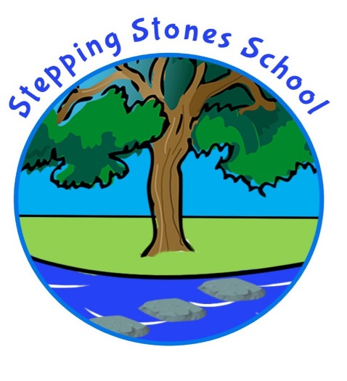

Healthy Eating Policy 2023-24

Written by: K Greenwood
To be reviewed: Sep 2024

Together at Stepping Stones School we strive for all children to become independent and confident learners. We enable children to achieve their potential within a creative and challenging curriculum delivered through high quality teaching. We nurture a positive environment where adults and children respect each other within a safe and caring community.

This policy links to our PSHE policy aim:
• To encourage our children to make healthy choices about their lives

And to our PE and Physical Activity policies:
• We aim to promote and encourage healthy lifestyles

And to the National Curriculum 2014, where it states Knowledge, skills and understanding to be taught:
• Developing healthy, safer lifestyles

At Stepping Stones School we believe that education about health issues is very important for the development of our pupils both now and for the future. We acknowledge the important link between a healthy diet and the ability to learn effectively. We aspire to improve the health of our school community by teaching ways to establish and maintain life long healthy eating habits.

Our Aims:
• To further develop and maintain an ethos in the school in which a healthy choice is the easy choice
• To encourage a healthier and calmer population of children and young people
• To ensure all children have a suitable lunch time meal that sustains and prepares them for their afternoon learning
• To provide cross-curricular education that enables pupils to make an informed choice
• To involve the whole community in developing and maintaining healthy eating and drinking habits
• To have a safe, pleasant and sociable dining experience which enhances the social development of all children
• To encourage a balanced diet
• To encourage fluid intake with an easily accessible water supply throughout the day
• To take into account and accommodate dietary requirements
• To ensure high standards of hygiene amongst the children
• To develop healthy eating and drinking habits that will last a lifetime
• To ensure the safety of children with allergies is given diligent attention
• To be at all times consistent with medical, religious and cultural needs of the children.

Our objective is to work towards ensuring that this policy is both accepted and embraced by governors, school management, teachers and support staff, pupils, parents, food providers and the wider community.

Provision of Food and Drink across the Day:
Our policy on the provision of food and drink within the school day complies with the National School Food Standards. It ensures consistency for healthy eating for packed lunches in addition to school dinners whilst ensuring food at other times of the day also follow the standards.

Mid-morning Snack - Children are provided with a piece of fresh fruit or vegetable each day.
We provide a dedicated snack time where adults and children share time together.
Packed Lunches – We encourage healthy packed lunches and regularly keep parents informed on suitable packed lunch options to help promote healthy choices.
School Meals - School lunchtime meals are made on site by our housekeeper following a balanced diet menu created by her and her team. They have to meet the healthy food standards as set out by the government.

The school recognises the particular value of school meals to all children, including those from low-income families. The system for free school meals is actively promoted to parents by the school and a nondiscriminatory process is used.

Dining Room Environment:
The school recognises:
• The importance of lunchtime organisation on the behaviour of pupils
• The value of promoting social skills
All staff on duty at lunchtime all work together to create a good dining ambience and the development of appropriate table manners. There is no segregation of children bringing a packed lunch and those having a hot meal. Children sit together in their house groups supported by their house and vice captains.

Drinks Policy:
Children are encouraged to drink plain water throughout the day, particularly after PE, active play and in hot weather.
All children are able to bring a clear water bottle to school, which should be labelled with their name. Fizzy drinks and energy drinks are not allowed.

Treats and Rewards:
Whilst endeavouring to encourage healthy eating as the norm, we also accept that at times it may be appropriate to enjoy less healthy options as an occasional treat. Examples include:
• Crisps, chocolate biscuits and sweets, e.g. at the Christmas party
• Treats brought into school by children to share with their class on the occasion of their birthdays
• Popcorn or chocolate during a film event
• Sweets, fizzy drinks, cakes etc. for sale at a fundraising event for school.

Curriculum, Teaching and Learning:
Key healthy eating messages will be taught within Science, DT and PSHE. They may also be delivered through other curriculum areas as well as through theme days/weeks.
Opportunities are taken whenever possible to encourage pupils to taste multi-cultural aspects of food through cross-curricular subjects including Geography, History and RE. Children are encouraged to taste new foods by school staff. Activities will support children in understanding the provenance of food and develop an interest in preparing and eating food, with the knowledge of a healthy balanced diet.

Children with Special Needs:
Inclusion is seen as fundamental to both the planning and delivery of work relating to healthy eating. The work is matched to the age and maturity of the pupils and due regard is given to children with SEN requirements. School also recognises that some children and staff require specialist diets, including food allergies. The schemes of work are sensitive to this and the teachers will be aware of any pupils within their class who this may apply to. Information is requested from parents on admission regarding any allergies and this is updated annually. Prior to residential trips, a form is sent home which includes information on dietary needs.

Involvement of all stakeholders:
All new parents are made aware of this policy. Key headlines are published on the school website and through our social media channels. Feedback from the school community (pupils, families, governors, school staff) is encouraged. Information about school catering is provided in school newsletters e.g. menus and theme days and on our website.

Food Hygiene:
The school seeks to provide a safe, secure learning environment that enables children and young people to gain accurate Knowle ge, develop their own values and attitudes, and develop skills to grow into happy confident and healthy adults. The school aims to ensure all members of staff are positive role models.
Children are reminded on a regular basis about the importance of hand washing before preparing and/oreating food and after handling any animals.

Monitoring and Assessing the Policy:
This policy is monitored by the senior leadership team. It will be reviewed on a planned one year cycle, with views of the whole school community taken into consideration, including those of
pupils.
We encourage children to make healthy food choices through education, adult modelling and praise.
We are keen to ensure that all children have had adequate, healthy food to sustain their afternoon learning.
When a child hasn’t eaten much, then they will be encouraged to eat a little more. If this happens regularly, families will be told.

