

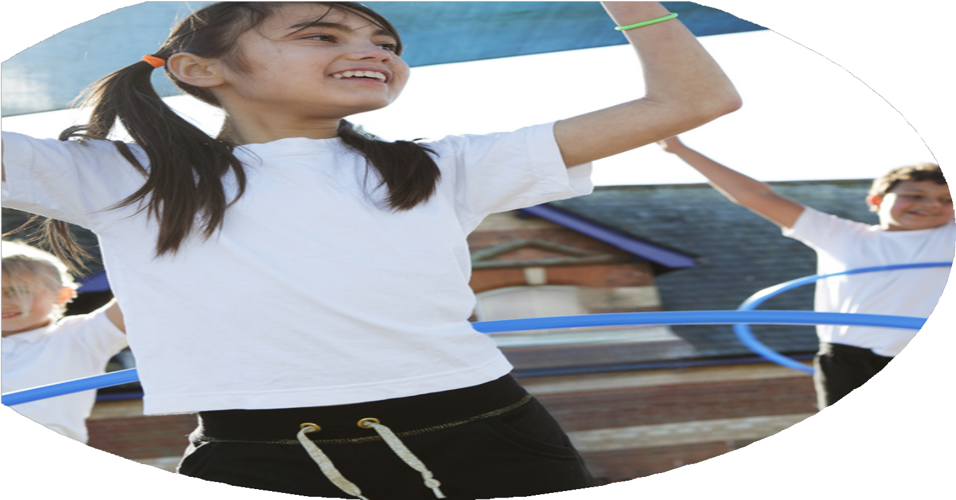





Stepping Stones Short Stay School PE Funding


Evaluation Form

Commissioned by

Created by

PE Funding Evaluation Form

It is intended that this template should be used as preparation for the completion of the statutory digital reporting tool being introduced this academic year. You can upload data (including swimming) from this template onto this platform once it becomes accessible.
Before you decide how you are going to use the funding for this academic year you should reflect and evaluate the impact of your use of the funding in 2023/24.
All spending of the funding must conform with the terms outlined in the Conditions of Grant document. The template is a working document that you can amend/update during the year.
Based on your evaluation of last year’s funding you should decide what you intend to do this academic year, how you will do it, and what impact you expect it to have.

It is important that the funding is used effectively and based on your school’s needs.
You must use the funding to make additional and sustainable improvements to the PE and sport in your school. You must develop and add to the PESSPA activities that your school already offers.

Summative digital reporting from June 2025 will continue to include swimming and water safety information therefore funding can be used to provide top-up lessons where necessary to ensure pupils meet national curriculum swimming requirements.

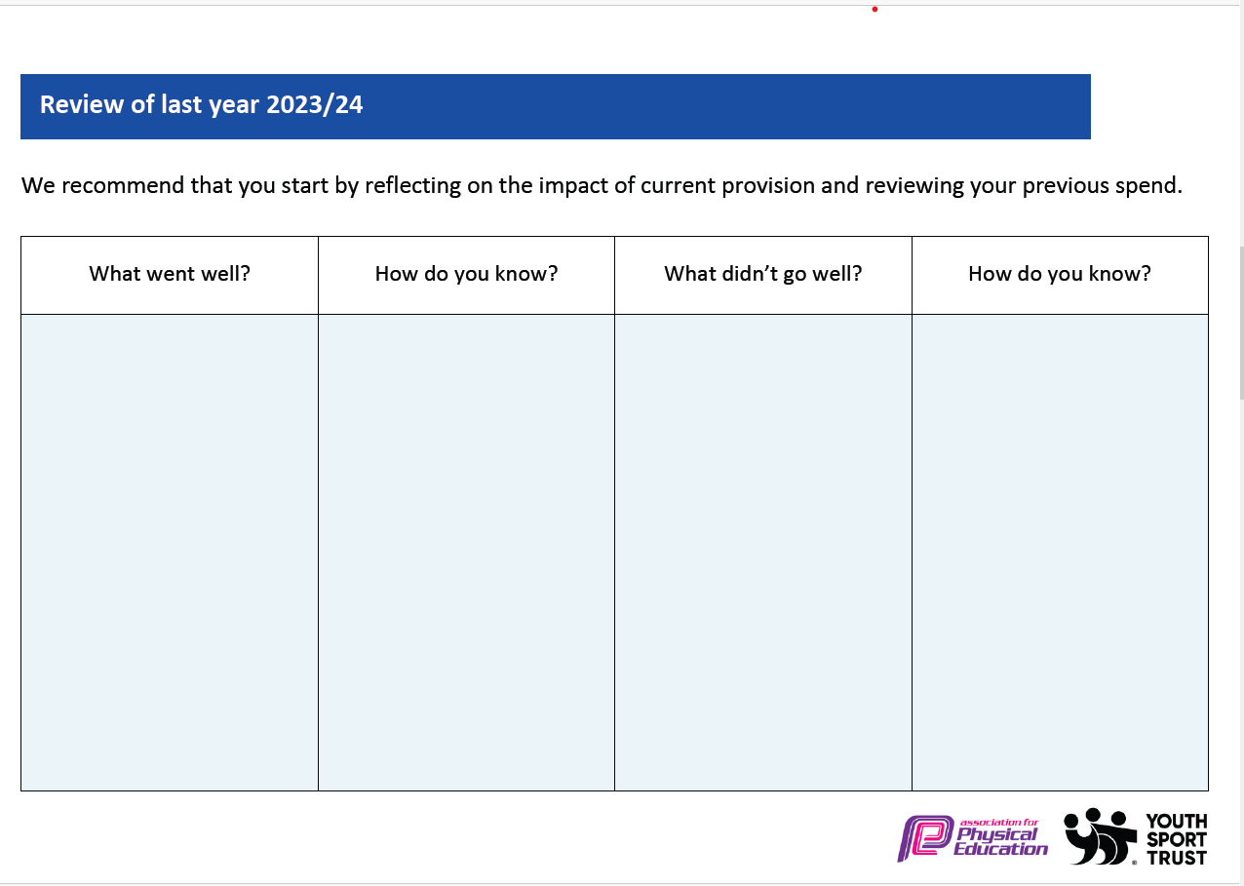

What are your plans for 2025/26 | How are you going to action these plans?
Intent | Implementation
- Purchase purposeful playground equipment that engages pupils, enhances physical activity and provides sustainability within the subject.  - Continue to provide new opportunities for our pupils.  - Improve physical activity and increase the heart rate of our children more frequently on a daily basis.  - Each class dedicates at least one PE session per half term to activities specifically designed to promote wellbeing and SEMH. | - Working closely with pupils to find interests and provide activities that pupils want to participate in. Pupil feedback will lead to the equipment that is purchased. House captain will also lead activities at playtime which will support their development and give those pupils a feel of responsibility.  - Ask Pupils What They Want: Survey students on their interests and what new activities they'd like to try (e.g., archery, climbing, martial arts, dance). This directly informs our choices and increases buy-in. Continue to trial New Activities in Short Blocks: Introduce 1-2 new activities each term for 2-3 sessions as "tasters." Use local coaches or staff with hidden talents to deliver these. Build Community Links: Partner with local clubs or facilities to offer taster sessions or pathways for students to continue activities outside school, providing diverse experiences.  - Start the Day Actively: Begin each school day (e.g., during tutor time) with a 5-10 minute energiser like a quick circuit, dance, or team challenge to boost focus and mood. Embed "Brain Breaks" in Lessons: Encourage all staff to use 2-5 minute physical "brain breaks" during academic lessons to re-energise pupils and improve concentration. Provide them with easy-to-use ideas. Boost Active Playtimes: Provide engaging physical activities and equipment during breaks and lunchtimes, potentially training older pupils as "Play Leaders" to run games.  - Plan Dedicated SEMH Sessions: Schedule one PE session per class, per half-term, specifically for wellbeing activities like yoga, non-competitive team challenges, or mindful nature walks. Train Staff in SEMH PE: Provide staff with training on delivering these activities, focusing on accessible movements, cooperative games, and how to facilitate post-activity discussions about feelings and teamwork. Reflect and Connect: End each SEMH-focused session with a short reflection on how the activity made students feel or what they learned about managing emotions, reinforcing the link between movement and wellbeing.

