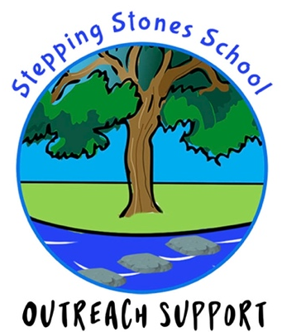

Outreach Support Request
for
Specialist Teacher Consultation

Name of School:

Contact Telephone Number:
Headteacher:
SENCO:
Name of Referrer:
Contact Email:
Date of Request:
Briefly outline reason for referral: | e.g. SENCO support, EHCP support, hourly support work with child/staff member etc

If the support is for a child please complete the box below:

Name of Child:

Year Group:
Male / Female:
Date of Birth:
EHCP? | Yes/No (Please delete as appropriate).  If yes, please identify category of need:

EXTERNAL AGENCIES INVOLVED (Please tick and give dates)

CAMHs
Educational Psychologist
Social Care
Speech and Language
Other (please identify)

If the support is for a child or class, please outline the current support and strategies that are being used and are successful:

What do you aim to achieve following our intervention? i.e. improved relationships, upskilled staff, improved emotional regulation, etc.

Please Note: Payment is required in full for all booked packages of support, regardless of cancellation. By booking our services, you agree to our cancellation policy, as detailed on our website, which stipulates the conditions when charges apply even if the support is cancelled.

PLEASE ENSURE THE PARENT/CARER SIGNS THIS REQUEST FORM – IF APPLICABLE
(this can be collected on the first visit)

Name and relationship of adult with Parental Responsibility:

Parental/Carer Consent I confirm that I have discussed the reasons for and purpose of the above request with school staff and confirm that I wish to have Stepping Stones Specialist teacher involvement with my child, as referred to above. I confirm that I have parental responsibility. I understand that any written report or other documentation will be sent direct to the school SENCO, who will then send this documentation to me.

Parent/Carer signature:

Please return the completed form and accompanying documentation to:
Katie Greenwood
Email: k.greenwood@steppingstones.lancs.sch.uk

GPDR DATA STORAGE: Please note we supply mainstream schools with copies of reports and reviews. We only hold information on our digital server until your child completes their primary education.

