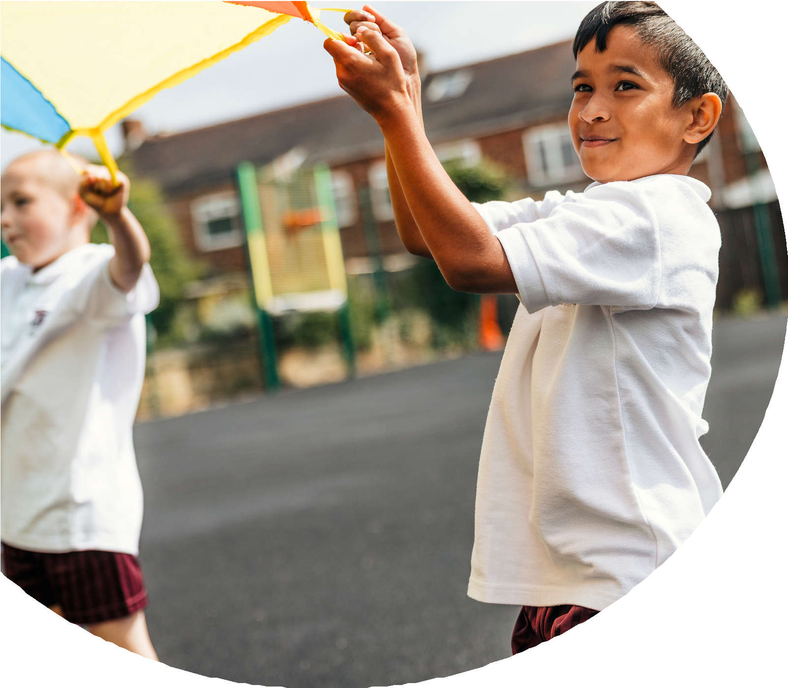
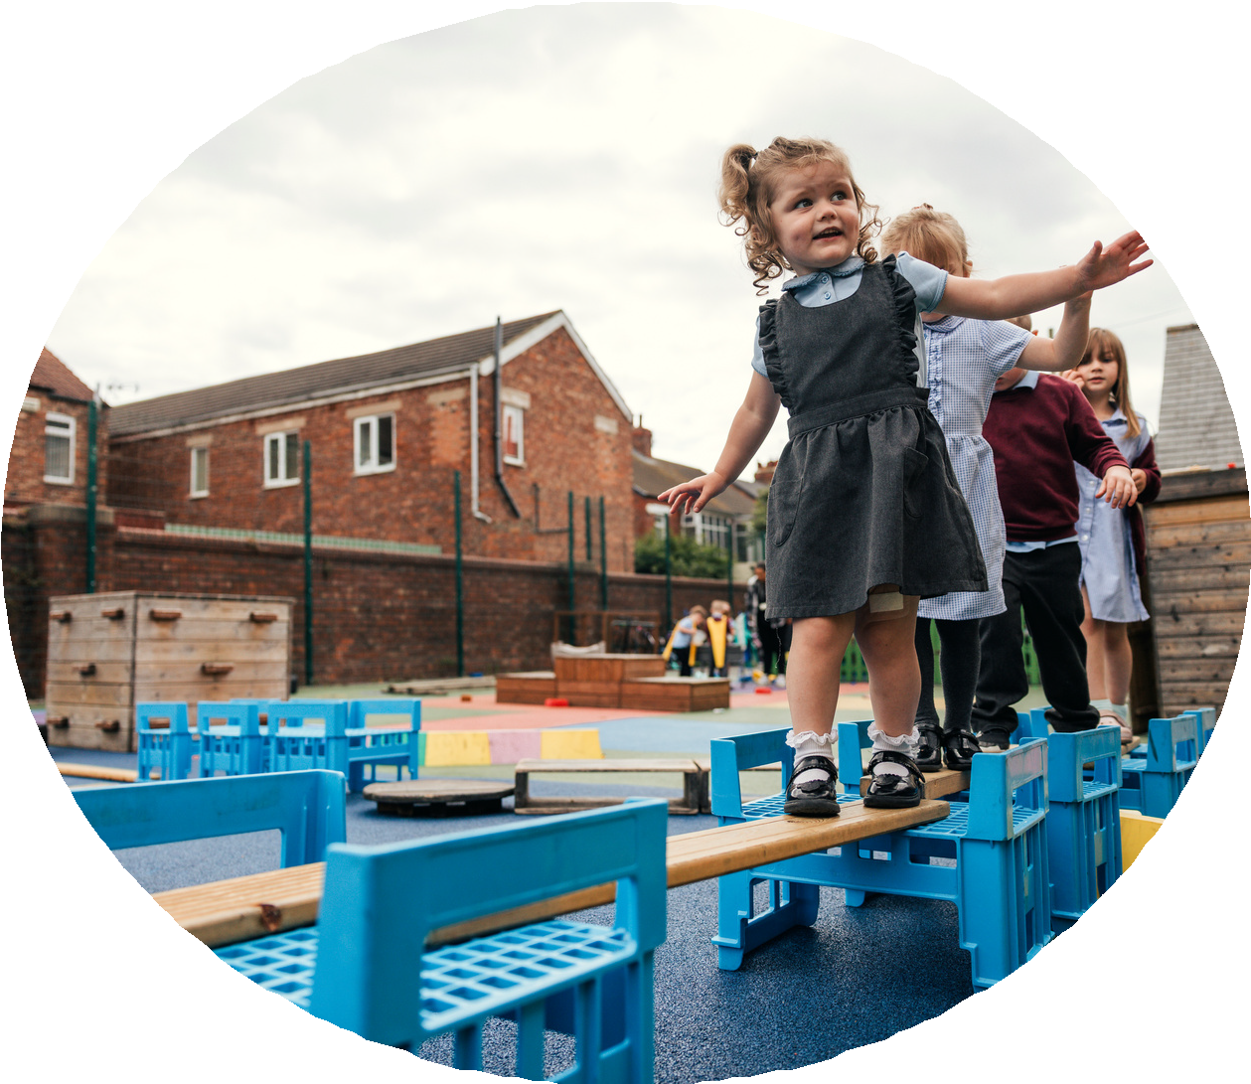

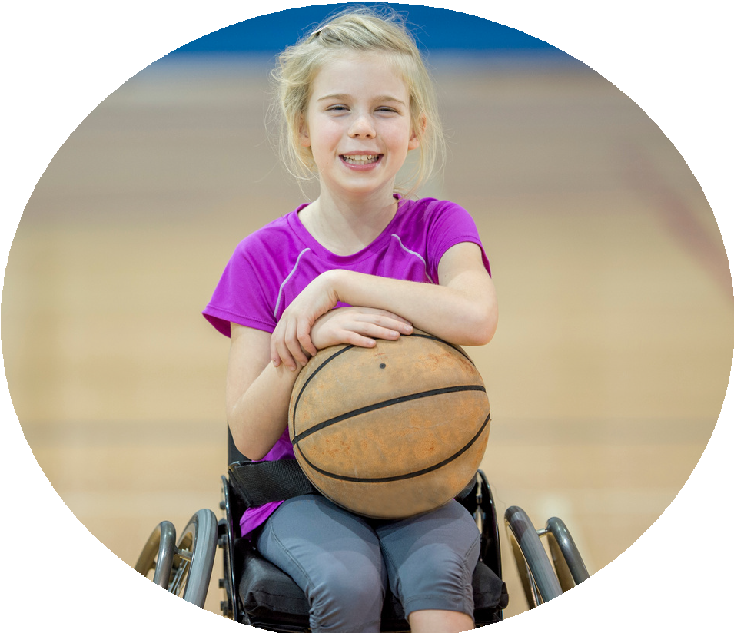



PE and sport premium monitoring and tracking form 2025/2026

Commissioned by

Created by


PE and sport premium monitoring and tracking form
- It is intended that this template should be used as preparation for the completion of the statutory DfE PE and sport premium digital expenditure reporting return. You can upload data (including swimming) from this template onto this platform once it becomes accessible.
- The template is a working document that you can amend and update during the year.
- Before you decide how you are going to use the funding for this academic year you should reflect and evaluate the impact of your use of you PE and sport premium funding in 2024/25.
- You should use your evaluation of last year’s funding to help you decide what to do this academic year, how you will do it, and what impact you expect it to have.
- All spending of the funding must conform with the terms outlined in the conditions of grant
- The summative digital expenditure reporting from June 2026 will continue to include swimming and water safety information. PE and sport premium funding can be used to provide top-up lessons, where necessary, to ensure pupils meet national curriculum swimming requirements
- To ensure funding is used effectively and based on your school’s needs; guidance and examples of best practice across schools can be found here.
- You must use the funding to make additional and sustainable improvements to the PE and sport in your school.
- You must develop and add to the PESSPA activities that your school already offers.

Useful Links:
- PE and sport premium for primary schools - GOV.UK
- PE and sport premium: conditions of grant 2025 to 2026 - GOV.UK
- It is intended that this template should be used as preparation for the completion of the statutory DfE PE and sport premium digital expenditure reporting return. You can upload data (including swimming) from this template onto this platform once it becomes accessible.
- The template is a working document that you can amend and update during the year.
- Before you decide how you are going to use the funding for this academic year you should reflect and evaluate the impact of your use of you PE and sport premium funding in 2024/25.
- You should use your evaluation of last year’s funding to help you decide what to do this academic year, how you will do it, and what impact you expect it to have.
- All spending of the funding must conform with the terms outlined in the conditions of grant
- The summative digital expenditure reporting from June 2026 will continue to include swimming and water safety information. PE and sport premium funding can be used to provide top-up lessons, where necessary, to ensure pupils meet national curriculum swimming requirements
- To ensure funding is used effectively and based on your school’s needs; guidance and examples of best practice across schools can be found here.
- You must use the funding to make additional and sustainable improvements to the PE and sport in your school.
- You must develop and add to the PESSPA activities that your school already offers.

Useful Links:
Complete the PE and sport premium expenditure reporting return - GOV.UK
PE and sport premium for primary schools - GOV.UK
PE and sport premium: conditions of grant 2024 to 2025 - GOV.UK

Review of the last academic year (2025/2026)

Swimming and Water Safety | What went well? Supporting evidence? | What didn't go well? Supporting evidence?
1. Swim competently, confidently and proficiently over a distance of at least 25 metres | This academic year we managed to take two classes swimming for a sustained period of time. This allowed out year 6 cohort to access top up swimming. For some of our pupils this was the first opportunity to attend an off-site experience. We achieved 50% of our pupils who attended the sessions regularly were able to swim over 25 metres which is an amazing achievement. | Due to staffing/Pool used for other things we were unable to carry out as many swimming lessons as possible this affected pupils:  Using a range of strokes effectively.  Perform safe-rescue in different water-based situations.  Taking as many pupils as possible to carry out top up swimming.
2. Use a range of strokes effectively (for example, front crawl, backstroke and breaststroke) | Whilst carrying out the top up swimming session pupils have worked on been confident in the water as the first step. From there pupils have then worked on using a variety of strokes using aids to build confidence. As the pupil’s confidence grew less aids were needed and pupils over time were able to effectively use a range of strokes.
3. Perform safe self-rescue in different water-based situations | Once confidence grew with the group, we the looked at water safety and different water-based situations. All pupils that attended the swimming session were able to recall the process of carrying out different scenarios in which they could keep themselves and others safe. Due to the area we are in I feel this is an amazing achievement as the local area has canals and rivers which can become unsafe.
- Take some time to reflect on your intent, implementation and impact from last academic year to celebrate your wins but to also think about improvements for the year ahead.
- You do not need to complete every box. Just record the information that is key to your school's priorities and areas of focus.
Remember - Be clear about how you focussed spending on key groups such as SEND, girls and disadvantaged pupils.

Review of the last academic year (2025/2026)
Key areas as outlined in PE and sport premium guidance | What went well? Supporting evidence? | What didn't go well? Supporting evidence?
1. Increasing confidence, knowledge and skills of all staff in teaching PE and sporting activities prioritising CPD and training where needed | Staff have made notable progress in developing their confidence to teach PE and lead sporting activities. Through the use of observed coached sessions, colleagues have been able to refine their practice, reflect on effective strategies and apply these more consistently in their own teaching. This supportive approach has helped to reduce uncertainty and strengthen staff capability across a range of physical education contexts.  The PE scheme, Get Set 4 PE, has also contributed significantly to whole-school consistency. Its structured planning, clear progression and accessible resources have ensured that lessons are delivered with greater coherence and that expectations are aligned across year groups. As a result, staff have benefited from a shared framework that supports secure subject knowledge and more effective lesson delivery | Despite the progress made, there remains a clear need for further professional development to ensure that all staff, including teaching assistants, feel fully confident in delivering high-quality PE. Some colleagues continue to require additional support in areas such as subject knowledge, practical activity leadership and adapting lessons to meet the needs of all pupils.  Moving forward, targeted CPD for all staff, including TAs, would strengthen confidence and improve understanding across the PE curriculum. A more sustained programme of training would help to address gaps in expertise, promote consistent practice and ensure that every member of staff is well equipped to support pupils effectively in PE and sporting activities.
2. Increasing engagement of all pupils in regular physical activity and sporting activities | Pupils, particularly the younger pupils, have shown a marked increase in engagement in PE lessons since September. They have sustained their participation for longer periods of time and have demonstrated a greater ability to remain focused on the set tasks. As a result, an increasing number of pupils have successfully achieved the lesson objectives with confidence and enthusiasm. Their willingness to listen carefully to instructions, respond promptly to teacher guidance and persevere through activities has contributed to stronger progress overall.  In addition, there has been evidence of improved enjoyment and readiness to take part in a wider range of physical activities. Younger pupils have responded positively to structured routines and clear expectations, which has supported their active involvement and helped to build consistency in participation. | Older pupils found it more difficult to participate effectively in larger groups, particularly during competitive sporting activities. In these contexts, some pupils were less confident in taking part, while others became distracted by the scale and intensity of the activity. This occasionally reduced the level of engagement and limited the extent to which all pupils could contribute fully.  Furthermore, the competitive nature of some group activities appeared to affect the participation of certain older pupils, especially those who were less assured in their sporting ability. As a result, additional support, clearer roles and more carefully structured group sizes may be required to ensure that all pupils are enabled to engage confidently and consistently in future physical activities.
3. Raising the profile of PE and sport across the school, to support whole school improvement | From September, pupils, particularly the younger pupils, have demonstrated strong engagement in PE lessons for increasingly sustained periods of time. Their ability to remain focused and participate positively has improved, reflecting a growing enthusiasm for physical activity. PE has also proved to be an effective vehicle for developing secure relationships between staff and pupils, as well as among peers. Through collaborative tasks and structured activities, pupils have shown increasing determination and a greater willingness to persevere when faced with challenge. In addition, they have begun to understand the importance of teamwork, learning to communicate more effectively, support one another, and work collectively towards a shared goal. These positive developments have contributed to a more purposeful ethos and have supported wider whole-school improvement. | Despite these strengths, the planned Sports Week could not be delivered due to a particularly busy curriculum and competing whole-school priorities. This meant that an important opportunity to celebrate sport on a broader scale, involve the wider school community, and further raise the profile of PE was lost. As a result, some pupils did not have access to the enriched sporting experiences that had been intended. Future planning will need to allow greater flexibility to ensure that such events are protected within the school calendar and are not compromised by curriculum pressures.
4. Offer a broader and more equal experience of a range of sports and physical activities to all pupils and ensure equal access to sport for boys and girls | Through the use of specialist coaches, pupils have experienced a broad range of sporting and physical activities. This has enabled them to participate in new sports and to develop positive attitudes through the successful completion of unfamiliar skills. The curriculum offer has been carefully adapted to meet the needs of all pupils, including those who may otherwise find PE and sport a barrier to participation. This inclusive approach has supported greater confidence, improved engagement and wider involvement across year groups.  In addition, the Winmarleigh outdoor adventure sessions have provided valuable off-site opportunities for pupils to extend their experiences beyond the classroom. These visits have supported the school’s key values, particularly resilience, as pupils have been encouraged to persevere, problem-solve and respond positively to challenge. The provision has helped to ensure that boys and girls have had equitable access to a varied and enriching sporting offer. | Due to the demands of a busy curriculum, there have been limitations in the range of additional opportunities available. As PE subject leader, I would always wish to provide more experiences for pupils in order to further broaden participation and raise engagement. Unfortunately, as in previous years, we have been unable to organise a sports week or secure the giant climbing wall on site. These remain valuable development areas and are opportunities that we will continue to pursue moving forwards in order to strengthen access for all pupils.
5. Increasing participation in competitive sport | Coaches have worked diligently to provide rich opportunities for pupils to participate in friendly, in-house competition. These carefully structured events have enabled a greater number of pupils to experience the excitement of competitive sport in a supportive environment. As a result, pupils have developed stronger collaborative skills, learning how to communicate effectively, share responsibility, and contribute positively to a team.  In addition, such opportunities have helped pupils to build resilience. They have begun to understand that winning and losing are both integral elements of sport, and that each outcome offers valuable lessons in perseverance, sportsmanship, and self-reflection. This positive approach has supported confidence, improved engagement, and encouraged pupils to take part more readily in a range of sporting activities. | The breakdown of the house system, caused by staff turnover, has had a negative impact on participation in competitive sport. This loss of structure has reduced the frequency and visibility of whole-school competition, limiting opportunities for pupils to engage in healthy rivalry beyond the curriculum of Physical Education.  As a school, we will look to re-establish the house system, as this would provide a more consistent framework for competition across the school day. Reintroducing it would create additional opportunities for healthy competition, strengthen school identity, and promote wider participation not only within PE lessons, but also through organised events, active playtimes, and inter-house activities.

Aims for the next academic year (2026/2027)
- Using your whole school priorities, school development plan and previous PE, school sport and physical activity data, set out your aims for the year ahead.
- Think about specific areas of need such as inactive girls, SEND and disadvantaged pupils
- Remember to also input your swimming data and reflections in the table located at the bottom of this page.
- Consider which of the 5 key areas improvements will be focussing on:
- Increasing confidence, knowledge and skills of all staff in teaching PE and sporting activities prioritising CPD and training where needed.
- Increasing engagement of all pupils in regular physical activity and sporting activities
- Raising the profile of PE and sport across the school, to support whole school improvement
- Offer a broader and more equal experience of a range of sports and physical activities to all pupils and ensure equal access to sport for boys and girls
- Increasing participation in competitive sport
Swimming and Water Safety | Input data | Reflections
1. Swim competently, confidently and proficiently over a distance  of at least 25 metres | 75%+ | This academic year, swimming provision at Stepping Stones has been highly positive and has contributed significantly to pupils’ physical development, confidence, and enjoyment. We have been able to take pupils from Years 3 to 6 to participate in top-up swimming lessons, and this has supported those who needed additional opportunities to consolidate essential water confidence and swimming skills. The experience has been valuable in ensuring that more pupils have been given the chance to make progress in a structured and supportive environment. The impact of these lessons has been evident not only in the water, but across the wider school community. Pupils have approached the sessions with enthusiasm and, in many cases, with growing self-assurance. The opportunity to attend top-up swimming has helped to reinforce resilience, perseverance, and a willingness to challenge themselves. It has also strengthened the school’s commitment to promoting healthy, active lifestyles. The next step moving forward is to sustain this positive momentum and aim to involve more pupils from the two younger classes. Extending access at an earlier stage would build confidence sooner and have an even more positive impact across the school.
2. Use a range of strokes effectively  (for example, front crawl, backstroke and breaststroke) | 75%+
3. Perform safe self-rescue in different water-based situations | 75%+

Aim | Why? | Key area | Supporting evidence
To ensure pupils continue to access a broad and inclusive PE curriculum. | A varied curriculum enables success, enjoyment, and equitable participation for all learners. | Inclusion, adaptability, and curriculum entitlement. | Differentiation, specialist resources, and careful sequencing increase accessibility and maximise achievement.
To improve pupils’ understanding of health, fitness, and lifelong activity. | Pupils benefit from recognising the relationship between exercise, wellbeing, and healthy choices. | Healthy lifestyles and informed decision-making. | Discussions, reflection, and practical experiences deepen understanding and support sustained habit formation.
To promote competition, teamwork, communication, and respectful interaction. | PE provides a powerful context for practising cooperation, turn-taking, and self-control. | Personal, social, and emotional development. | Small-sided games and explicit social expectations foster collaborative behaviour and reduce conflict.
Aims for the next academic year (2026/2027)

Plan, monitor and evaluate (2026/2027)
- Please aim to use this as a live working document through the year.

- Keep returning to this to evidence adaptations and progress made through the PESSPA opportunities you provide.

- There is no set number of objectives you must have.

- Make as many or as few as you see fit that will support your aims for the year ahead.

- Consider which of the 5 key areas improvements will be focussing on:
- Increasing confidence, knowledge and skills of all staff in teaching PE and sporting activities prioritising CPD and training where needed.
- Increasing engagement of all pupils in regular physical activity and sporting activities
- Raising the profile of PE and sport across the school, to support whole school improvement
- Offer a broader and more equal experience of a range of sports and physical activities to all pupils and ensure equal access to sport for boys and girls
- Increasing participation in competitive sport

Plan, monitor and evaluate (2026/2027)
Your Objective: To ensure pupils continue to access a broad and inclusive PE curriculum.

 | Intent – what is your objective? | Implementation - How will you achieve this? | Impact - What do you hope to see? | Supporting evidence
Plan and monitor | To ensure pupils continue to access a broad and inclusive PE curriculum. | The PE curriculum will be reviewed annually to ensure full coverage of team, individual and aesthetic activities. Medium-term plans will be adapted to remove barriers to participation and to provide appropriate challenge for all pupils. Staff will receive regular professional development on adaptive teaching, safe practice and inclusive grouping. Resources will be audited to ensure equitable access for pupils with SEND, medical needs and differing physical confidence. Pupil voice, lesson observations and participation data will be used to refine provision throughout the year. | Pupils will demonstrate higher levels of engagement, improved confidence and sustained participation across a wider range of physical activities. All learners should experience success, develop physical literacy and understand the value of lifelong physical activity. Disadvantaged pupils and those with additional needs will access the curriculum with minimal exclusion or modification that restricts entitlement. | Lesson visits, participation registers, assessment records, pupil voice feedback and curriculum maps will evidence improved access and breadth.
 | What impact have you seen? | Are the improvements sustainable? How? | Supporting evidence | Approx. cost
Evaluate

Your Objective: To improve pupils’ understanding of health, fitness, and lifelong activity.

 | Intent – what is your objective? | Implementation - How will you achieve this? | Impact - What do you hope to see? | Supporting evidence
Plan and monitor | To improve pupils’ understanding of health, fitness, and lifelong activity. | The curriculum will be strengthened through explicit teaching of the principles of health, fitness, recovery and personal wellbeing. Pupils will participate in structured lessons, practical fitness tasks and reflective discussion, with clear links made between physical activity, mental health and long-term lifestyle choices. Assessment for learning will be used to identify misconceptions, whilst differentiated activities will ensure appropriate challenge and inclusion. Staff will model accurate vocabulary and support pupils in setting personal targets. | Pupils will demonstrate secure knowledge of the benefits of regular activity, improved ability to evaluate their own fitness, and greater confidence in explaining how exercise supports healthy living. Increased engagement, improved participation and more informed decision-making about personal wellbeing should be evident. | Evidence will include pupil voice, lesson observations, assessment outcomes, participation records and analysis of target-setting logs.
 | What impact have you seen? | Are the improvements sustainable? How? | Supporting evidence | Approx. cost
Evaluate

Your Objective: To promote competition, teamwork, communication, and respectful interaction.

 | Intent – what is your objective? | Implementation - How will you achieve this? | Impact - What do you hope to see? | Supporting evidence
Plan and monitor | To promote competition, teamwork, communication, and respectful interaction. | Structured activities will be embedded within lessons and enrichment opportunities, including paired tasks, small-group challenges and inter-house competitions. Clear expectations for collaboration, turn-taking and respectful language will be established explicitly and revisited regularly. Staff will model constructive communication, assign rotating roles, and use concise success criteria to reinforce fairness, resilience and mutual support. | Pupils will demonstrate improved cooperation, more confident verbal exchange and a stronger willingness to participate. Healthy competition should increase motivation, while teamwork should enhance problem-solving and shared responsibility. Respectful interaction will be evident through courteous dialogue, inclusive behaviour and a reduction in conflict. | Evidence will include lesson observations, pupil voice, behaviour logs, participation records and work scrutiny. These sources will indicate whether pupils are engaging appropriately, sustaining collaboration and responding positively to competitive tasks.
 | What impact have you seen? | Are the improvements sustainable? How? | Supporting evidence | Approx. cost
Evaluate

Your Objective:
 | Intent – what is your objective? | Implementation - How will you achieve this? | Impact - What do you hope to see? | Supporting evidence
Plan and monitor

 | What impact have you seen? | Are the improvements sustainable? How? | Supporting evidence | Approx. cost
Evaluate

Your Objective:

 | Intent – what is your objective? | Implementation - How will you achieve this? | Impact - What do you hope to see? | Supporting evidence
Plan and monitor

 | What impact have you seen? | Are the improvements sustainable? How? | Supporting evidence | Approx. cost
Evaluate

This page has been left blank for any notes or supporting information.

